
Team Assignment 09
HIT
3/17/2012

Software Measurement and Analysis

Team members: | Members ID
Giang Thị Ha Thanh | T097828
Trần Dũng Đạt | T095716
Nguyễn Vũ Trọng Giang | T096656
Huỳnh Chấn Huy | T096498
Tạ Quang Hiệp | T090363
Nguyễn Trần Hồng Phúc | T095014

Each team analyzes the provided Viking product defect data and submits a report on their findings. In addition, each team lists their recommendations for steps that should be taken to ensure that quality is not an accident for the Viking project based on the defect data (<3 pages total). As input to this exercise you should have access to the following file:
- [Spreadsheet] Viking Project Defect Data.xls
- Metrics
  - Intended Audience
- Functional Test Manager
- Project Manager
- Change Control Board (CCB)
- Functional test team members

  - Goal / Question / Metric
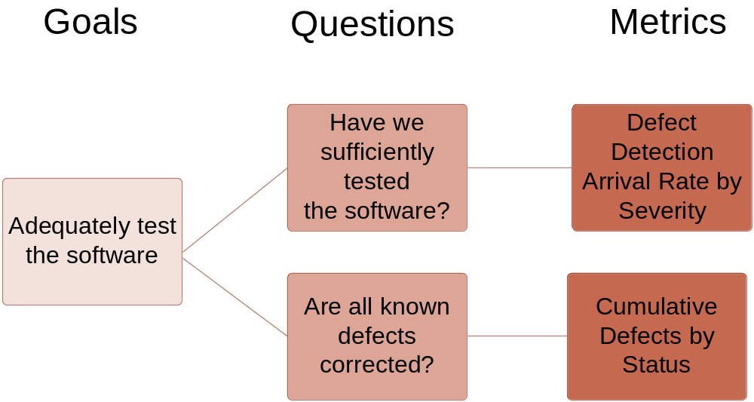

- Defect Life Cycle
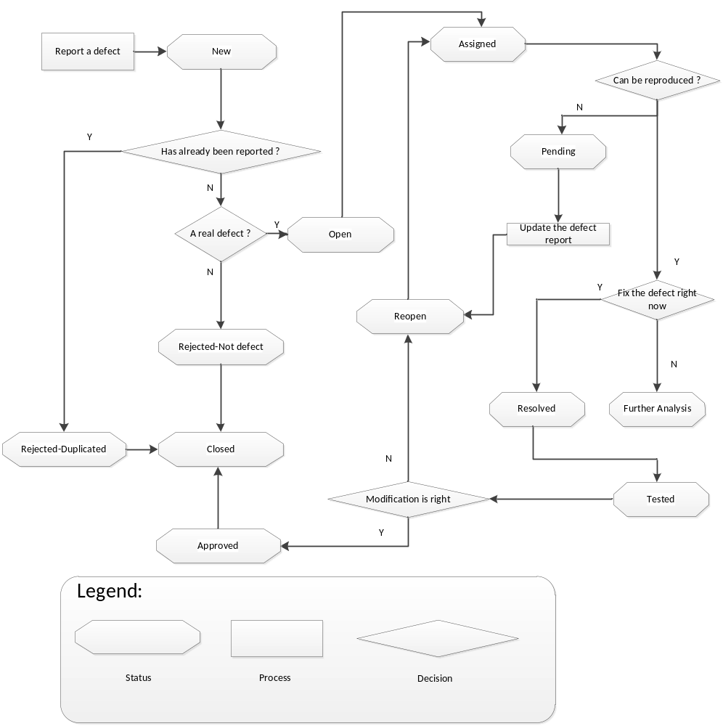

Defect life cycle describes a process to manage defects or defects with different status.
Firstly, the tester performs a function test and found out a defect, he reports a new defect on a program which used to manage defect life cycle (such as: TFS or something like that). He creates a status which is new for this defect.
Secondly, if the developer – who take charge this function that was tested and find out the defect – suppose that the defect has already been reported, he will change defect’s status into Rejected and describes briefly a defect is “duplicated” and the tester reconfirm it and change the status into closed. Else the defect is supposed that not to report and go to the next step.
Thirdly, the developer keeps check if it is a real defect. If it is true, the developer will change the status into open. If it isn’t, the developer will change the status into Rejected and describes briefly a defect is “not defect” and the test reconfirm it and change the status into closed.
Fourthly, the defect is assigned for a developer to fix.
- If the developer suppose that the defect can’t be reproduced and need more info, he will change into pending and the test will check the defect, give more defect information (for example, how is the defect occurred? listed step by step), update the defect report and change the status into reopen. After then, the defect will re-assign for the developer who fix this defect.
- Else if the defect can be reproduced, the developer is going to fix the defect right now. If the defect is too hard to resolve and need further analysis, the developer will change the status into further analysis. Else if the defect can fix, the developer is going to resolve the defect and changes the status into resolved.
Fifthly, the tester reviews this solved-defect and change the status into tested. If the tester supposes that the defect isn’t fixed yet, the tester will change the status into reopen; else if the defect is fixed successful, the status change into approved and the tester close the defect.

- Defect Detection Arrival Rate by Severity Metric
  - Metric Requirement Statement
To evaluate the detection arrival rate by severity of defect in this release in order to deliver our software product with required quality and insure that all known defects are corrected before shipment.
  - Standardized Definitions
Severity Levels: The importance of the problem, as defined by the customer (typically based on the problem’s impact on the user). There are four levels of Severity:
1 – Critical
2 – High
3 – Medium
4 – Low
  - Decision Criteria
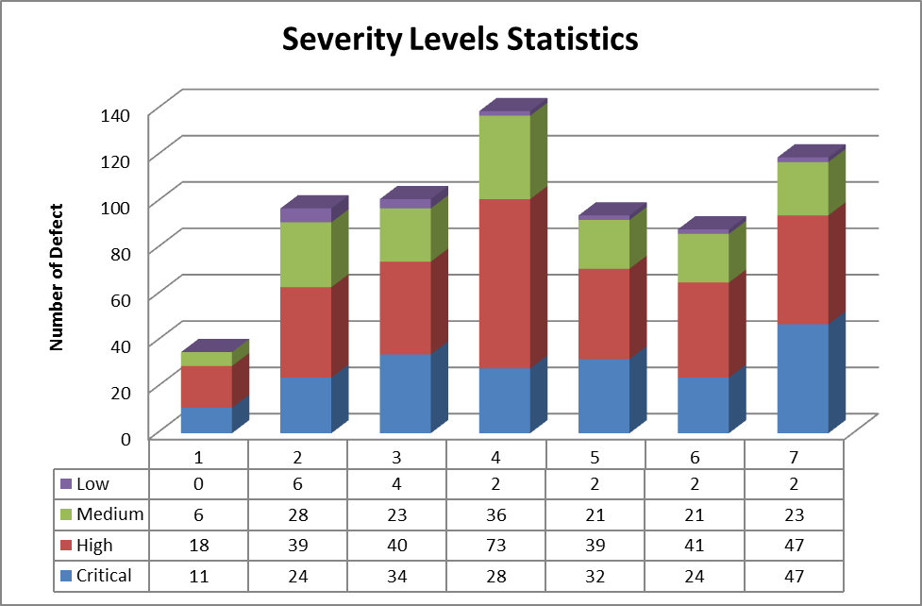
Look at the chart, we can see that:
- All week has defects and the number of defect quickly increase starting from week 2
- Week 4 has the highest number of defect with 139 defects and it has signs of decrease in two weeks later.
- Critical level defect and High level defect are rise almost all week and highest in week 7.
General, the number of defect is still high after 7 weeks of work and this is a bad sign for this project.

- Cumulative Defects By Status
  - Metric Requirements Statement
To evaluate the number by status of the known defects in this release in order to deliver our software product with required quality and ensure that all know defects are corrected before shipment.
  - Standardized Definitions
Status | Status Meaning
Open | New, not yet assigned
Reopen | A defect that was previously Closed, Pending or Rejected has been Reopened. Typically this means that the Customer or QA has been able to reproduce the defect.
Rejected | From the evaluation it has been determined that this is either not a defect or it can't/won't be resolved.
Further Analysis | From the evaluation it has been determined that additional analysis is required
Pending | Additional information has been requested from the person who submitted the defect
Approved | The defect has been approved for resolution
Assigned | The defect has been assigned to a software engineer who will work on the defect
Resolved | The software engineer responsible for fixing the defect believes that the defect is fixed. Typically this means that the updated product passes all unit and integration tests.
Tested | The defect is considered resolved by the QA team
Closed | The updated product is available for release. Sometimes the original defect submitter is responsible for closing defects, but often this isn't possible.

  - Assumption and comment
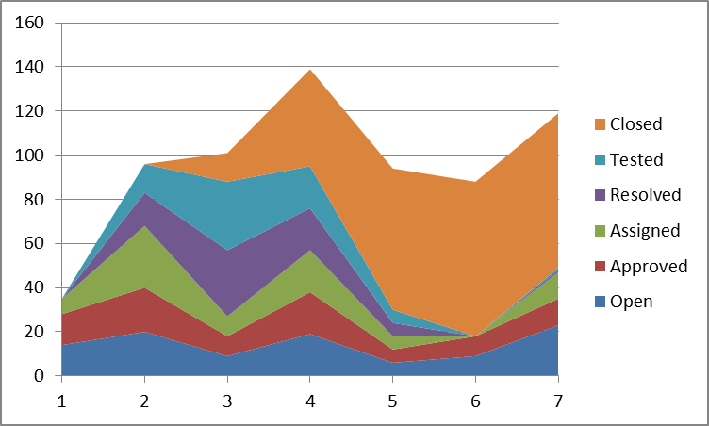
Cumulative Defects by Status

Assumption from chart:
- Defect collection was performed before beginning time in Viking_Product_Defect_Data.xls file.
- There was defects had been opened before was closed in Viking_Product_Defect_Data.xls file.
- The beginning time of Viking_Product_Defect_Data.xls file will be assume at the start time of testing phase.
- The testing phase lasted for 15 weeks, so the data only show the status of defects at half way of testing phase.
Comment: The project team worked quite well, there have defects has been opened before starting the testing phase , for 7 weeks testing team worked and has 261 defect closed, the defects arising until the seventh week is 100. So the project team has a fix and close defects from the previous stage with good performance.

- Recommendations
Based on the defect data, we list as follow to recommend ensuring that quality is not an accident for the Viking project:
- Have defined process to control quality, especially defect control.
- Collect defect frequency and record them to easy access and control.
- Defect life cycle must be conduct at the early of project, there for we can easily fix and reduce the project cost.
- Defect life cycle must be must be performed seriously and accurately to ensure no defect was omitted, no found defect was ignored.
- Based on chart Severity levels statistics on section 2.4 we can see on 4th week, the defect increase, the recommend here is we should add more human resource to make sure the defects will be fixed as much as possible, not to them a burden for the next weeks.
- Similarly, at 7th week, we can see the critical defects was found increase, we must focus and fixed as the purpose not to let them affect the system in the next weeks.

- Related Document
Viking_Product_Defect_Data.xls (Excel file)

